Instructions for Preparing

Decision Package Submissions

For Agency Amendment Requests

2014-2016 Biennial Budget – Amended Session



Department of Planning and Budget
October 2014

TABLE OF CONTENTS
Decision Package Overview 1
About the Decision Package Submission 1
Technical and Non-Technical Decision Packages 1
Enterprise Priorities and Strategies 2
Enterprise Priorities and Strategies Listing 2
Strategic Link 5
Personal Services 6
Benefit Rates 6
Requests for Salary Increases 7
Nonpersonal Services 7
Detailed Nonpersonal Services Subobject Codes 7
Allowable Nonpersonal Services Convenience Codes 9
Components 9
Nongeneral Fund Revenue Source 9
Rate Adjustments 9
Reports 10
Decision Package Module Detailed Instructions - 11
Decision Package Module Quick Guides 11
Overview Tab Overview 13
Overview Tab Instructions 13
Narratives Tab Overview 16
Narratives Tab Instructions 16
Budget Summary Tab Overview 17
Budget Summary Tab Instructions 17
Budget Detail Tab Overview 18
Budget Detail Tab Instructions 19
Position Planning Tab Overview 19
Position Planning Tab Instructions 20
Components Overview 23
Components Instructions 23
NGF Revenue Source Overview 24
NGF Revenue Source Instructions 24
Rate Adjustment Tab Overview 25
Rate Adjustment Tab Instructions 25
Decision Package Prioritization Instructions 26
Decision Package Prioritization Overview 26
Decision Package Prioritization Instructions 26
Decision Package Bulk Submit Instructions 27
Bulk Submit Overview 27
Bulk Submit Instructions 27

Decision Package Overview

About the Decision Package Submission
This package provides guidance and instructions for the submission of decision packages to be considered as amendments to the 2014 Appropriation Act. This submission is due to DPB by October 31, 2014.
You will be using the following modules in the Performance Budgeting System to complete this submission: 1) Decision Packages, 2) Decision Package Prioritization, and 3) Decision Package Bulk Submit to DPB. These modules can be found on the “Operating Budget” menu on the Performance Budgeting system work tray/main screen.
Detailed instructions on the use of the Performance Budgeting system modules are included later in this package. However, this package also highlights some topics you should pay closer attention to such as Commonwealth enterprise strategies, objectives and measures, personal services, non-personal services, components, nongeneral fund revenue sources, rate adjustments, and available reports.

Technical and Non-Technical Decision Packages

Please note that technical adjustments are considered to be just one category of decision packages. As such, you will use the decision package module to submit technical adjustments as well as any non-technical decision package you would like to propose. If you intend for a budget request to be considered as a technical adjustment, you should categorize it as “Technical Adjustment” in the “Category” field of the decision package “Overview” tab.
A technical adjustment is a proposal to modify your agency’s budget that does not involve changes in policy or significant budgetary impact. Technical adjustments are very similar to base adjustments with respect to items such as the removal of one-time costs; the transfer of dollars or positions between programs or service areas, accounting for additional nongeneral fund revenues that involve no policy changes, and accounting for an increase in position level to reflect actions already approved administratively.
A non-technical decision package is a proposal to modify your agency's budget or to modify language in the Appropriation Act that results in a new initiative, a change or clarification in policy, or a significant budgetary impact. Each decision package should address one budget action only. Each action should be a discrete unit that can be evaluated on its own merit independent of any other proposals.
If you are not sure whether or not a request should be categorized as a technical adjustment or submitted under a non-technical category, contact your DPB budget analyst for guidance. Otherwise, the request should be submitted as a non-technical decision package.
Note: You should not submit decision packages that reflect the savings as submitted through your cabinet secretary as part of this submission.

Enterprise Priorities and Strategies

Enterprise priorities and strategies provide agencies an opportunity to link budget decision packages to the priorities and strategies of particular significance to the Commonwealth.

As you develop your agency’s budget decision packages, consider whether any of your requests have a relevant link to the enterprise strategies. If they do, please select the most appropriate item in the “Enterprise Strategy” drop down menu in the decision package module. If there is no relevant link to the enterprise strategies, you should not make a selection. A list of enterprise priorities along with associated enterprise strategies is shown in the next several pages. Look through this list to see if any of your decision packages match with any of these strategies.
Enterprise Priorities and Strategies Listing
Economy

Business Climate and Economic Development: Promote Virginia’s competitive business climate to maintain the designation as the best state for business.
Poverty: Develop a clear and consistent anti-poverty policy.
Diversity: Attract businesses to the Commonwealth that operate in new and growing fields in the 21st century economy. Targeted areas include cyber security and biosciences.
Exports: Enhance Virginia’s trading relationship with international partners.
Energy: Promote a diverse and reliable energy supply.

Education

Achievement Gap: Improve educational success in struggling schools in high poverty communities and expand access to quality early education for all children
K12 Education: Promote great teaching and learning through accountability reform, emphasize creativity and critical thinking skills, and strengthen support for teachers and educational leaders
Pathways to the 21st Century Workforce: Strengthen pathways in K-12, community colleges, and throughout higher education, increasing affordable completion of high-demand degrees and credentials
Higher Education Access and Affordability: Continue to strengthen Virginia’s system of community colleges and four-year institutions and promote greater access and affordability for all Virginians.

Health and Family

Healthcare Accessibility: Advance access to high-quality health care for more Virginians.
Behavioral Health: Strengthen Virginia’s behavioral health system in partnership with hospitals, law enforcement, free clinics and community health centers, private providers, consumers, family members and advocates.
Nutritional Divide: Promotes strategies to improve nutritious options for Virginians in at-risk circumstances.
Healthcare Innovation: Embrace innovative models of care and new technologies to improve health outcomes and lower costs.
Women’s Health: Protect women’s rights to make their own healthcare decisions.
Children and Families: Promote strategies that encourage a culture of health through stable housing, access to high-quality health care and proper nutrition.

Public Safety and Homeland Security

Public Safety: Protect our citizens and ensure everyone lives in a safe community.
Homeland Security and Emergency Preparedness: Ensure Virginia is prepared to address threats to the safety and security of the Commonwealth and to respond rapidly and efficiently to emergencies.
Gun Violence: Pursue strategies to ensure all gun owners undergo a background check when purchasing a firearm.
Sexual and Domestic Violence: Aggressively target sexual and domestic violence for prevention and enforcement.
Smart Sentencing: Promote improvements to the sentencing process to recognize and treat the root causes of crime thereby reducing recidivism.
Restoration of Rights: Maximize restoration of voting rights for individuals who qualify.

Veterans and Military Families

Workforce: Create seamless transitions for Virginia’s veterans with high quality education and workforce services that accelerate career opportunities.
Homeless: Increase affordable housing opportunities and veterans support programs.
BRAC: Retain and reinforce Virginia’s military installations and defense activities.
Family Support: Ensure that Virginia remains the preeminent state for military personnel, their families and veterans.

Workforce

Supply and Demand: Align Virginia’s workforce to meet current and anticipated employer demands with career pathways and training solutions for dislocated, underemployed, and future workers.
Credentialing: Establish annual goals and identify ways to increase statewide credentials that align with employer current and future needs.
New Skills: Facilitate in-demand skills sets for Virginia’s new economy, while fostering private sector innovation and entrepreneurship.

Natural Resources

Chesapeake Bay Restoration: Protect and improve the health of the Chesapeake Bay, by making every effort to meet the goals for nutrient reduction outlined in the federal government’s cleanup plan.
Land Conservation: Implement a targeted, strategic land conservation plan that protects Virginia’s biodiversity and public access.
Climate Change: Prepare the Commonwealth for the effects of climate change and reduce the state’s contribution to its causes.

Transportation

Prioritization: Develop a transparent, data-driven prioritization model to help determine allocations of transportation funding and ensure ongoing accountability.
Multi-Modality: Expand the role of non-highway modes of transportation in the Commonwealth’s transportation network.
Engagement: Guarantee that local governments and citizens play a meaningful role in transportation decision-making.

Government and Citizens

Transparency: Collaborate across secretariats to improve citizens’ access to government data and decision-making processes.
Supplier Diversity: Ensure that Small-Women-and-Minority owned businesses are afforded representative access to government procurement.
State Workforce Succession: Improve recruitment, retention, and succession planning for the state workforce.
Innovation: Explore and pursue innovative strategies to increase government efficiency or to reduce government costs for needed services.
Fiscal Stewardship: Manage public resources efficiently and effectively in challenging economic conditions.
- Cyber Security and Upgraded Technology: Enhance current technology platforms and infrastructure while protecting all data.
- Ethics: Promote a culture within state government that values strong ethics.
Customer Service: Deliver high quality products and services to customers in a timely manner.
- Accessibility: Encourage user-friendly online services for all citizens.

Strategic Link

You should skip the “Strategic Link” grid for this year’s submission. For Executive branch agencies that participate in strategic planning in the Performance Budgeting system, there is a grid on the “Overview” tab in the decision package module that was developed to allow for the linking of your decision package requests to applicable objectives and/or measures in your latest published strategic plan. At the time of the issuance of these instructions, this grid is configured to pull data from the old Performance Budgeting system strategic planning modules and is currently being reconfigured to pull published information from the new strategic planning modules. In addition, even in the new module, objectives and measures for the 2014-2016 biennium have not been fully published at this time, therefore, you should not attempt to link strategic plan data for this submission.

Personal Services

Benefit Rates
If any of your decision packages involve personal services, you should use the rates included in the table below as applicable.

Sub Object | Benefit |  | Decision Package  Rates/Factors¹
1111 | VRS Retirement Contributions
 | State Employees |  | 12.33%
 | Virginia Law Officers Retirement (VaLORS) |  | 17.67%
 | State Police (SPORS) |  | 25.82%
 | Judges (JRS) |  | 51.66%
1112 | Social Security ² |  | 6.20% capped at $113,700
1112 | Medicare |  | 1.45%
1114 | Group Life |  | 1.19%
1115 | Annual Employer Health Insurance Premiums
 | COVA Care | Single | $6,348
 | COVA Care | Employee + One | $11,376
 |  | Family | $16,680
 | COVA High Deductible | Single | $5,472
 | COVA High Deductible | Employee + One | $10,164
 |  | Family | $14,844
 | HealthAware | Single | $6,348
 |  | Employee + One | $11,376
 |  | Family | $16,680
 | Kaiser Permanente | Single | $5,892
 | Kaiser Permanente | Employee + One | $10,476
 | Kaiser Permanente | Family | $15,312
1116 | Retiree Health Insurance Credit Premium |  | 1.05%
1117 | VSDP & Long-Term Disability Insurance |  | 0.66%
1118 | Teachers Insurance and Annuity³ Plan 1 |  | 10.40%
1118 | Teachers Insurance and Annuity³ Plan 2 |  | 8.50%
1119 | Defined Contribution Plan⁴ |  | 10.40%
1138 | Deferred Compensation Match Payments |  | One-half of employee’s contribution per pay period, up to a max of $20 per pay period or $480 annually
¹ Percentages refer to percent of salaries. Health insurance premiums are the annual employer dollar cost for an individual.
² The $113,700 Social Security cap applies to calendar year 2014. Future year caps are unknown at this time.
³ For institutions of higher education: This includes alternative retirement options, such as TIAA-CREF, for those employees as defined in § 51.1-126 of the Code of Virginia. Plan 1 employees are those employees hired before July 1, 2010. Plan 2 employees were hired after June 30, 2010.
⁴ Used for employees eligible for a defined contribution plan established pursuant to § 51.1-126.5 of the Code of Virginia.

Requests for Salary Increases
For requests involving additional funds for employee salaries, agencies should address the extent to which current salaries are recruiting, retaining, and motivating employees; how total compensation compares to what is offered by other relevant employers for similar positions; and the impact on the agency's ability to provide services and recruit, retain, and motivate employees. If you have any such requests you should include this explanation in the “Explanations and Methodologies” field on the “Narratives” tab of the decision package module.

Nonpersonal Services

You should provide as much detail as possible when arraying nonpersonal services. At a minimum, you should use the subobject codes listed in the table below if they are applicable to the anticipated expenses associated with your decision package request. The purpose of collecting budget information at the more detailed subobject level for these selected subobject codes is to better identify these areas of cost and to more completely understand the impact of agency based rate changes. In other cases, the subobject detail represents an area targeted for cost control and/or management, or an area where better tracking of costs are needed.
Any remaining dollar amount for nonpersonal services beyond those required in the list below may be grouped in the “xx95” convenience codes, which are listed on the following page. No other convenience subobject codes may be used. Please note that if you do choose to array nonpersonal services to “XX95” codes, your DPB budget analyst may request additional information about the requested amounts.

Detailed Nonpersonal Services Subobject Codes

1205 | Seat Management Services
1214 | Postal Services
1215 | Printing Services
1216 | Telecommunications Services (provided by VITA)
1217 | Telecommunications Services (provided by non-state vendor)
1218 | Telecommunications Services (provided by another state agency)
1241 | Auditing Services
1242 | Fiscal Services
1243 | Attorney Services
1244 | Management Services
1245 | Personnel Management Services
1246 | Public Informational and Public Relations Services
1247 | Legal Services
1248 | Media Services
1271 | Information Management Design and Development Services (provided by VITA)
1272 | VITA Pass Thru Charges
1273 | Information Management Design and Development Services (provided by another State agency (not VITA) or vendor)
1274 | Computer Hardware Maintenance Services
1275 | Computer Software Maintenance Services
1276 | Computer Operating Services (provided by VITA)
1277 | Computer Operating Services (provided by another State agency (not VITA) or vendor)
1278 | VITA Information Technology Infrastructure Services (Provided by VITA)
1279 | Computer Software Development Services
1292 | VITA Services Provided to Out of Scope Agencies
1321 | Coal
1322 | Gas
1323 | Gasoline
1324 | Oil
1325 | Steam
1326 | Wood Fuels
1431 | Categorical Aid to Local Governments and Constitutional Officers (Not Technology)
1432 | Payments in Lieu of Taxes
1433 | General Revenue Sharing
1434 | Disaster Aid to Local Governments
1435 | Special Payments to Localities
1436 | Categorical Aid to Local Governments and Constitutional Officers for Technology
1441 | Payments to Substate Entities
1442 | Payments to Individuals
1451 | Grants to Intergovernmental Organizations
1452 | Grants Nongovernmental Organizations
1453 | Out-of-State Political Entities
1455 | Disaster Cost Reimbursements to Other State Agencies
1456 | Disaster Aid to Nongovernmental Organizations
1511 | Aircraft Insurance
1512 | Automobile Liability
1513 | Flood Insurance
1514 | Inland Marine Insurance
1515 | Marine Insurance
1516 | Property Insurance
1517 | Boiler and Machinery Insurance
1521 | Computer Capital Leases
1522 | Central Processor Capital Leases
1523 | Computer Software Capital Leases
1524 | Equipment Capital Leases
1525 | Building Capital Leases
1526 | Land Capital Leases
1527 | Land and Building Capital Leases
1531 | Computer Rentals (not mainframe)
1533 | Computer Software Rentals
1534 | Equipment Rentals
1535 | Building Rentals
1536 | Land Rentals
1537 | Land and Building Rentals
1538 | Building Rentals – State Owned Facilities
1539 | Building Rentals – Non-State Owned Facilities (Payment administered by DGS)
1542 | Electrical Service Charges
1543 | Refuse Service Charges
1544 | Water and Sewer Service Charges
1547 | Private Vendor Service Charges
1551 | General Liability Insurance
1552 | Money and Securities Insurance
1553 | Medical Malpractice
1554 | Surety Bonds
1555 | Workers' Compensation
1561 | Computer Peripheral Installment Purchases
1562 | Computer Processor Installment Purchases
1563 | Computer Software Installment Purchases
2211 | Desktop Client Computers (microcomputers)
2212 | Mobile Client Computers (microcomputers)
2214 | Mainframe Computers and Components
2215 | Network Servers
2216 | Network Components
2217 | Other Computer Equipment
2218 | Computer Software Purchases
2219 | Development Tools Purchases
3111 | Bond Issuance Expenses
3112 | Bond Issuance Fees
3113 | General Obligation Bond Financing
3114 | General Obligation Bond Interest Retirement
3115 | Revenue Bond Financing
3116 | Revenue Bond Interest Retirement
3117 | Revenue Bond Principal Retirement
3121 | Anticipation Loan Interest Retirement – Not drawdown or mortgage loans
3131 | Anticipation Loan Interest Retirement – Drawdown and Mortgage Loans
3132 | Mortgage Loan Interest Retirement
3196 | Indirect Cost Recoveries from Auxiliary Programs for Obligations
3198 | Inter-Agency Recoveries for Obligations
3199 | Intra-Agency Recoveries for Obligations

Allowable Nonpersonal Services Convenience Codes

1295 | Undistributed Contractual Services
1395 | Undistributed Supplies and Materials
1495 | Undistributed Transfer Payments
1595 | Undistributed Continuous Charges
2195 | Undistributed Property and Improvements
2295 | Undistributed Equipment
2395 | Undistributed Plant and Equipment
3195 | Undistributed Obligations

Components

Components are a discrete portion of an agency’s budget that further breaks down its activities or services. You must allocate your agency’s decision packages across components. If a decision package requires the addition of a new component, please contact your DPB budget analyst.

For detailed instructions on completing the components tab in the decision package module, see the Performance Budgeting System instructions included later in these instructions.

Nongeneral Fund Revenue Source

If you are requesting a decision package for nongeneral fund appropriation that will require the collection of new or additional revenue above and beyond the base level of revenue included in your nongeneral fund revenue estimate, you should complete the NGF Revenue Source tab in the decision package module. If you are requesting nongeneral fund appropriation that can be supported by existing revenue collections, you can skip this tab.

For details on completing this tab, see the Performance Budgeting System instructions included later in these instructions.

Note: You will receive separate instructions on submitting updates to your agency’s overall nongeneral fund revenue estimates.

Rate Adjustments

If you are a central service agency that provides services to other agencies and charges rates for these services, you will need to complete the Rate Adjustment tab in the decision package module if you anticipate a change in those rates. You should also explain as in much detail as possible, the need for the rate adjustment and attach a spreadsheet showing the impact by agency in the Narrative tab.

For details on completing the Rate Adjustment tab, see the Performance Budgeting System instructions included later in these instructions.

Reports

You may run a report of your decision package submissions by clicking on the “BD 1.17 -Agency Budget Requests” report within the Performance Budgeting system reports menu. This report contains several options that allow you to run detailed reports on requested dollar amounts and authorized positions. In addition, the screen print below shows that there are options that allow the viewing of summarized information and the creation of a formatted report.
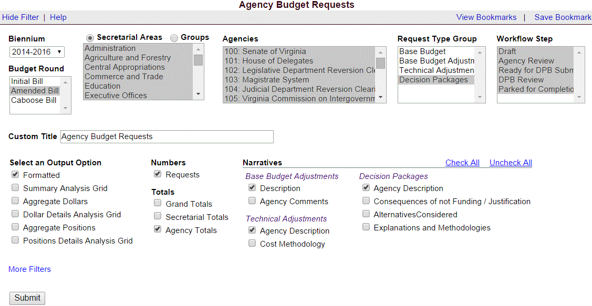

Decision Package Module Detailed Instructions -
Performance Budgeting System
The decision package module is used for proposals to modify your agency's budget or to modify language in the Appropriation Act. These proposals will be in the form of either non-technical requests or technical adjustments.

To access the decision package module, select “Decision Packages” within the “Decision Package sub-menu under the “Operating Budget” link on the Performance Budgeting System work tray / main screen.

If you have any questions of a policy nature, please contact your DPB budget analyst. If you experience technical issues with the Performance Budgeting System, please contact the VCCC help desk at vccc@vita.virginia.gov (make sure to indicate in the subject line that you are experiencing a Performance Budgeting system issue so that the ticket can be routed to the Performance Budgeting System help desk).

Decision Package Module Quick Guides

AGENCY ANALYST QUICK GUIDE
- Mouse over the Operating Budget functional area menu item and then mouse over Decision Packages. From the resulting dropdown menu, select Decision Packages and the Overview tab will appear.
- Complete the Overview tab as described in the Overview tab instructions.
- Complete the Narratives tab as described in the Narratives tab instructions.
- Complete the NGF Revenue Source tab as described in the NGF Revenue Source tab instructions. This tab only needs to be completed if there is an NGF Revenue impact for the decision package.
- Complete the Position Planning tab as described in the Position Planning tab instructions. This tab only needs to be completed if positions are requested or impacted by this request, including position reductions.
- Complete the Budget Detail tab as described in the Budget Detail tab instructions.
- Complete the Budget Summary tab as described in the Budget Summary tab instructions.
- Complete the Rate Adjustment tab as described in the Rate Adjustment tab instructions. Only complete this tab if you are a central service agency submitting a request for a rate adjustment.
- Click Submit and select the appropriate action from the available options.
  - Continue Working - Saves the decision package and returns the work item to the Available Work Items tab on the Work Tray for users with similar credentials to claim.
  - Submit for Agency Review - Submits the decision package to the next step in the workflow.
  - Void Document - Voids the decision package.

AGENCY REVIEWER QUICK GUIDE
NOTE: Ensure that all decision packages have been prioritized in the Decision Package Prioritization module. All decision packages must be prioritized before they can be submitted to DPB.
- Click on Available to be Claimed from the Work Tray.
- Select the Document Type filter and select Decision Package to filter on the decision packages.
- Click Claim next to a decision package that is ready for review. Once decision package is claimed, the Overview tab will appear.
- Review the Overview tab for completeness and accuracy. Refer to the DPB transmittal for any policy guidance.
- Click on the Budget Summary tab and review for completeness and accuracy. Refer to the DPB transmittal for any policy guidance.
- Click on the Narratives tab and review for completeness and accuracy. Refer to the DPB transmittal for any policy guidance.
- Click on the NGF Revenue Source tab and review for completeness and accuracy. Refer to the DPB transmittal for any policy guidance.
- Click on the Budget Detail tab and review for completeness and accuracy. Refer to the DPB transmittal for any policy guidance.
- Click on the Position Planning tab and review for completeness and accuracy. Refer to the DPB transmittal for any policy guidance.
- Click on the Rate Adjustment tab and review for completeness and accuracy. Refer to the DPB transmittal for any policy guidance.
- Click Submit and select the appropriate action from the available options.
  - Continue Review - Saves the decision package and returns the work item to the Available Work Items tab on the Work Tray for users with similar credentials to claim.
  - Ready For DPB Bulk Submit – Places the decision package in a batch to be submitted to DPB via the Decision Package Bulk Submit to DPB module. (Make sure you also rank the decision package in the Decision Package Prioritization module.)
  - Return for Further Data Entry - Returns the decision package to the data entry workflow step.
  - Void Document - Voids the decision package.

Overview Tab

Overview Tab Overview
The purpose of the Overview tab is to describe the decision package and select the level at which the budget details will be entered. Additionally, the ability to specify if new legislation or Appropriation Act language changes and attach a file related to those changes is provided.

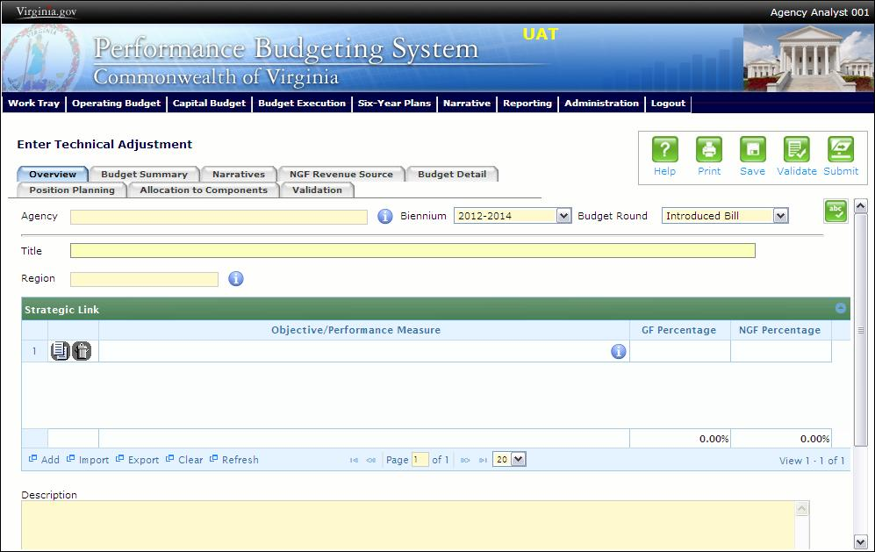
Overview Tab Instructions
- Click on the Overview tab.
- Select the Agency to which the decision package will be applied.
- Select the Biennium to which the decision package will be applied.
- Make sure the correct budget round is selected (initial budget, amended, or caboose).
- Enter the Title for the decision package.
Insert a short descriptive title. Remember that your title should begin with a verb such as increase, add, reduce, transfer, shift, expand, etc.
- Select the Category for the decision package.
Select the category that most closely defines the proposed strategy. The following list of categories represents typical request categories; if additional categories are needed they will be conveyed through the DPB transmittal.

  - Appropriation Act language only. This category is for proposals to add, delete, or modify language in the Appropriation Act. Proposals in this category should have no impact on the appropriation amounts.
  - Budget Reductions. This category is used by DPB to indicate decision packages that contain targeted reductions.
  - Caseload or workload adjustments. This category is for routine changes, either increases or decreases, in your agency’s budget to reflect cost adjustments involving changes in workloads or client loads. (Note: This category is NOT for budget proposals involving a change in the scope of services or the way your agency delivers services or does business.)
  - Emergencies. The request is essential to prevent or eliminate an immediate threat to life, safety, health, or property.
  - Information technology. This category is for proposals for information technology resources, including hardware, software (whether commercial packages or custom-developed), telecommunications equipment or services, and any related consulting, training, or support/maintenance services.
  - Mandates. The request is necessary to meet the requirements of a state or federal law or a court order. (Note: The definition of mandate is restrictive.) Requirements of state or federal regulations are not considered mandates per se. If a regulation or legislation simply enables or authorizes an activity but does not require it, the activity is not considered a mandate. This category should be used only if there is absolutely no alternative but to fund the request. It is anticipated that very few, if any, requests will fall within this definition.
  - New general fund spending initiatives. This category is for proposing new general fund spending initiatives that have not received prior approval from the Governor or Cabinet Secretary.
  - Operational efficiencies and service reductions. This category is for cost savings or efficiency measures that your agency proposes to implement or for proposals that produce cost savings by reducing the services or scope of services delivered to your agency's customers. Examples include phasing out or eliminating certain administrative activities or positions, reducing or eliminating discretionary expenses (printing, travel, etc.), or decreasing or eliminating current services.
  - Position level changes only. This category is for technical changes (increases or decreases) to position levels that have no other impact on appropriated amounts.
  - Reorganizations. This category is for proposals to transfer a program, service, or activity to another government entity (local, state, or federal), or to privatize. This category is for operational or organizational changes that will result in long-term cost-savings or benefits to the Commonwealth such as consolidating organizational units. This category also is for proposals that involve any agency reorganization that produces a need for additional agency resources (either funds or positions), or involves a policy issue. Examples include creating new organizational units or changing functional program units. Salary increases and regrades. Salary increases and regrades. This category is for salary increases due to position regrade/classification. (Note: This category is NOT for statewide salary increases or for new positions).
  - Savings Strategy. Select this category for decision packages that reflect savings strategies. Other targeted savings should use either the “Budget Reductions” or the “Operational Efficiencies and Service Reductions” categories.
  - Technical adjustments. This category is for technical or housekeeping adjustments that do not have an overall net general fund budget impact or do not involve policy decisions, such as to shift funds or positions between programs or service areas or to appropriate additional nongeneral fund revenue (such as a federal grant that is more than originally anticipated or will continue for an additional year).Unanticipated and unavoidable cost adjustments. This category is for increases or decreases in your agency's budget to reflect cost adjustments involving existing services or for adjustments to the rates charged by central service agencies for services used by other state agencies. (Note: This category is NOT for budget proposals involving a change in the scope of services or the way your agency delivers services or does business.)
  - VITA rate change requests. This category is for requests for funding required by any change in VITA rates charged to agencies.
  - Other spending or initiatives. This category is for any other proposals for additional resources that will require new or expanded services.

- You should skip the Strategic Link grid for the purposes of this submission. See the “Strategic Link” section of these instructions for more information.
- Select the Region of the state that the decision package most impacts. If it impacts more than one region, select "Multiple Regions".
- If applicable, select the statewide Enterprise Strategy that the decision package supports. It is not necessary to force a selection if the decision package does not clearly support any of the strategies listed. See the “Enterprise Strategies” section of these instructions for a listing of the possible selections.
- Enter the Agency Description for the decision package.
Summarize the actions your agency proposes to take with the requested dollars or positions. If the decision package is for language only, explain what the language will allow the agency to do. In addition, provide detailed information to indicate the need for the proposed service. Cite quantitative data wherever possible.
- Check Will new legislation be required as a result of this request? if new legislation is required as a result of the decision package.
- Check Is Appropriation Act Language required as part of this request? if Appropriation Act language is required for the decision package.
- Upload any supporting documentation for the decision package by clicking Browse, selecting the file to be uploaded, and clicking the Upload button.
Note: This will be required if either the check box about new legislation or new Appropriation Act Language is checked. Changes will be shown using the appropriate italics or strike-through.
- Check Show Cost Code and/or Show Project Code if the budget details for the decision package will be entered at the cost code level, operating project code level, or both.

Narratives Tab

Narratives Tab Overview
The purpose of the Narratives tab is to capture the justification for the decision package, including justification for any rate adjustments. Remember, quality is important! Decision-makers may have only your narrative as a basis for evaluating your agency's proposal. You will need to be as thorough as possible to explain what the proposal involves and why it should be funded.

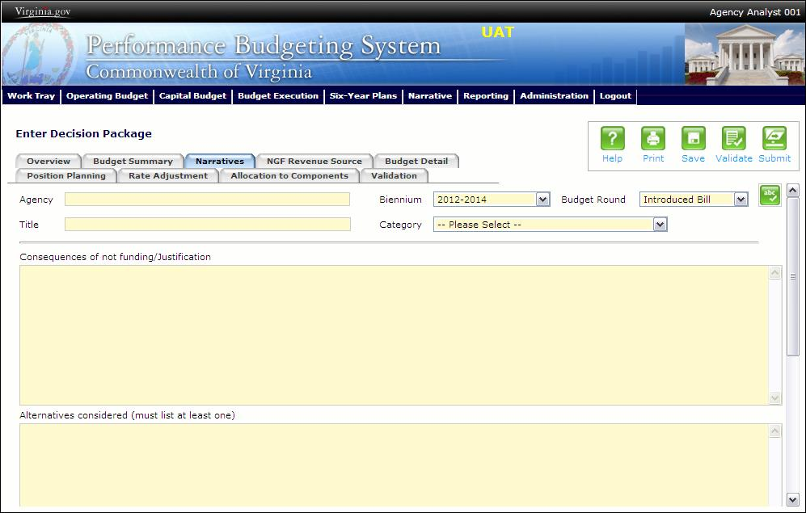
Narratives Tab Instructions
- Click on the Narratives tab.
- Enter the Consequences of not funding/justification.
Indicate the consequences you expect if your proposal is not approved. Detail how not funding this action will impact the agency's performance measures and targets.
- Enter the Alternatives considered (must list at least one).
Indicate any other alternatives you considered for accomplishing the objectives of the request and why you selected the proposed action. Briefly list the pros and cons of each alternative.
- Enter the Explanations and Methodologies.
Explain how you calculated your request and any assumptions used, the methodology used. Enter as much detail as necessary to fully explain the methodologies used. For requests involving additional funds for employee salaries, agencies should address the extent to which current salaries are recruiting, retaining, and motivating employees; how total compensation compares to what is offered by other relevant employers for similar positions; and the impact on the agency's ability to provide services and recruit, retain, and motivate employees.
- Attach any Supporting Documentation to further justify the need for the decision package.

Budget Summary Tab

Budget Summary Tab Overview
The purpose of the Budget Summary tab is to capture the high level general fund (GF) and nongeneral fund (NGF) six-year budget impact for the decision package. The information on this tab can be entered before the Budget Detail tab is completed as a placeholder if an agency is unsure if they are going to submit a decision package to DPB. If the Total Services grid on the Budget Detail tab has already been entered, the Summarize Budget functionality can be used to populate the first two years of the Summary of Costs and Positions grid based upon the data entered in the Total Services grid.
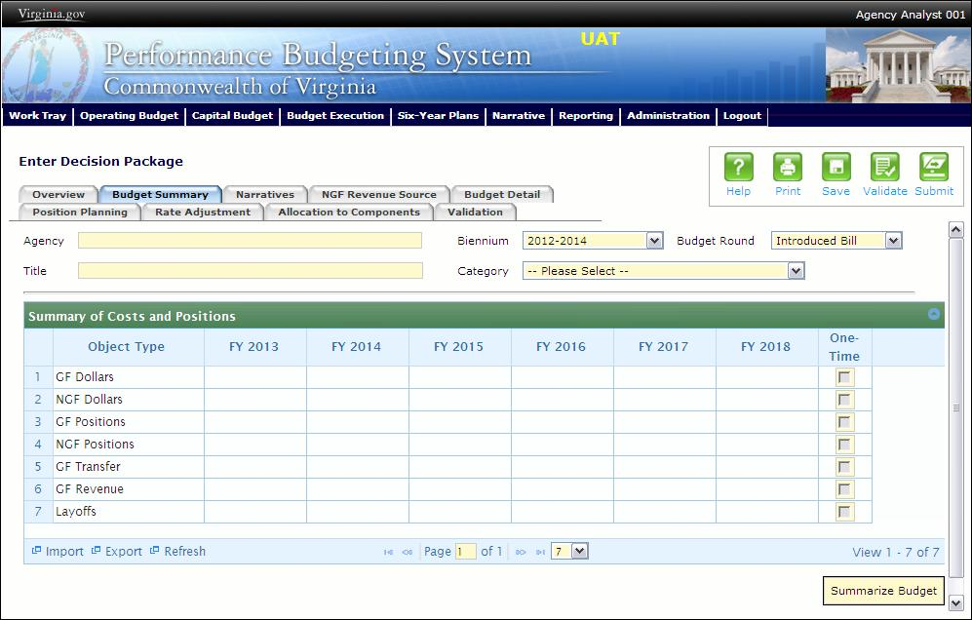
Budget Summary Tab Instructions
- Click on the Budget Summary tab.
- If the data has already been entered in the Total Services grid on the Budget Detail tab, click Summarize Budget. This will populate the GF and NGF data for the first two years in the Summary of Costs and Positions grid based upon the data entered in the Total Services grid on the Budget Detail tab.

- Enter the out-year impact for the decision package in the Summary of Costs and Positions grid and, if entering Budget Summary first, enter data for the two years of the biennium for which work is currently being completed. Agencies must enter data for all six years, even if the amount is zero.
- If the decision package results in a change in general fund resources/revenue, enter the amount in the applicable row at the bottom of the summary grid. "GF Transfer" is for nongeneral fund cash transfers to the general fund, "GF Revenue" is for changes in general fund revenue coming in to the Commonwealth, and "Additions to Balance" is for the reversion of general fund balances from agencies to the General Fund. For the most part, “GF Revenue”, “GF Transfer”, and “Additions to Balance” amounts should be entered as positive numbers and you should not attempt to spread these amounts to the corresponding “Total Services” grid on the “Budget Detail” tab.

Budget Detail Tab

Budget Detail Tab Overview
The purpose of the Budget Detail tab is to capture the budget details, line by line, for the decision package. A user will be required to enter the program (including service area), fund, subobject, and FY 20XX and 20XX dollars for each budget line associated with the decision package. If a user specifies that they will be budgeting at the cost code and/or project code levels, then they will be allowed to enter this level of detail when entering the budget details.

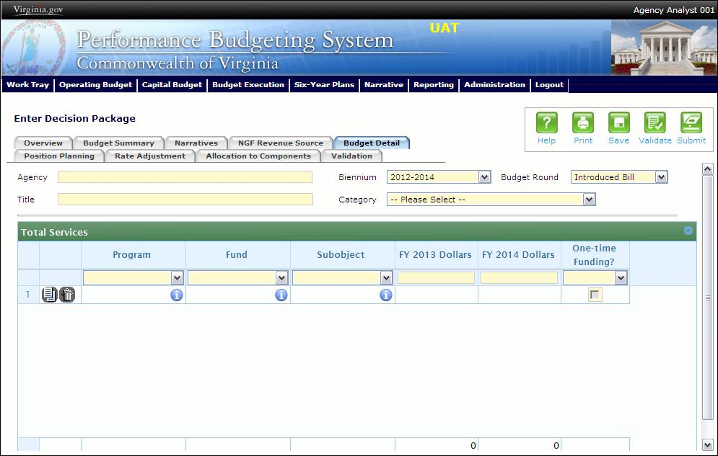

Budget Detail Tab Instructions
- Click on the Budget Detail tab.
- If applicable, confirm the personal services data that populated the Total Services grid from the Position Planning tab is correct. If the data is incorrect, return to the Position Planning tab to make corrections and then repopulate the data as described in the Position Planning tab instructions.
- In the Total Services grid, enter the Program (program, service area and component), Fund, and Subobject for each nonpersonal services budget line. Additionally, if applicable for the budget line, enter the Cost Code and/or Project Code.
- Enter the FY 20XX Dollars for the budget line.
- In the Total Services grid, if the budget line specified is one-time funding, then check the One-time Funding checkbox. If a budget line contains a mix of one-time and ongoing funding, create a separate line for the one-time amount and another for the ongoing funding requirements.
- Add rows to the Total Services grid as needed to specify multiple nonpersonal services budget lines by using the button.

Position Planning Tab

Position Planning Tab Overview
The purpose of the Position Planning tab is to capture position changes associated with the decision package. Once the positions are entered, the personal services budget can be automatically calculated and the resulting budget data can be used to populate the personal services subobjects in the Total Services grid on the Budget Detail tab. The position planning tab allows you to enter authorized position and salary information by either position or role which will in turn allow you to calculate the overall cost of new positions to include compensation and benefits. Alternatively, you may enter just the authorized position information by selecting the "Not Budgeting by Role or Position" option.

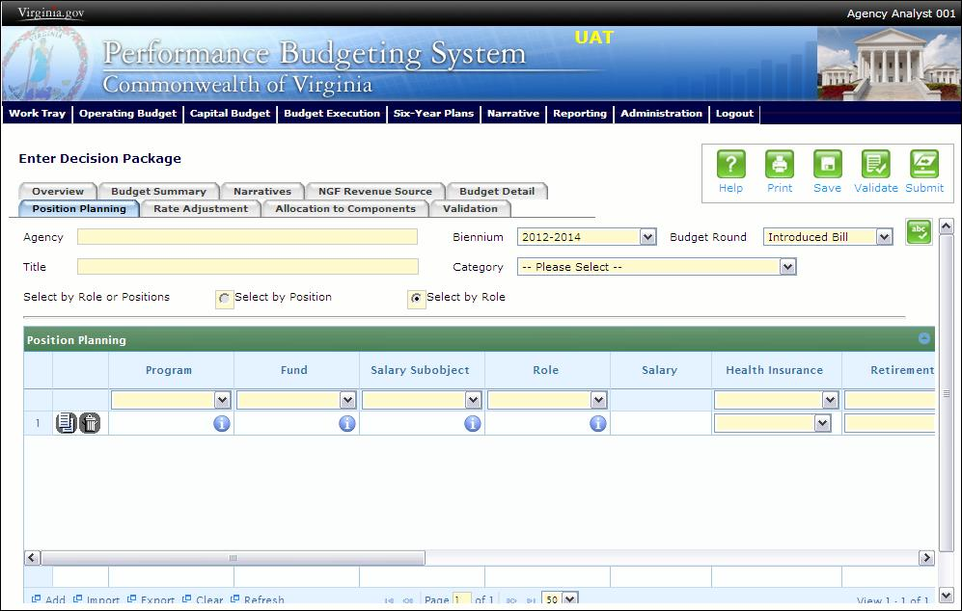

Position Planning Tab Instructions

Position Planning for Authorized Positions Only
Use this method if you do not need to calculate the cost of positions in the Performance Budgeting System and only want to record the authorized position level associated with the base adjustment.
- Click on the Position Planning tab.
- Check the Not Budgeting by Position or Role checkbox.
- In the Position Planning grid, enter the total number of positions for the Agency for both the first year and second years of the biennium in the FY 20XX Positions cells.
- Add rows to the Position Planning grid, by clicking the Add button in the lower left corner of the grid as needed.
- Authorized positions can also be uploaded from an .xls file.

Position Planning by Role
Use this method if you would like to use the capabilities of the Performance Budgeting System to assist in the calculation of the dollar costs of positions associated with the base adjustment.
- Click on the Position Planning tab.
- Select the Role radio button.
- In the Position Planning grid, enter or edit the Program, Fund, and Subobject for a role. Additionally, if applicable for the role, enter the Cost Code and/or Project Code.
- Select or edit the Role.
Enter the proper role title for the position you are requesting. Please contact the Department of Human Resource Management (DHRM), the DHRM website, or your agency human resource department for this proper role title.
- Enter or edit the Salary for the selected role.
Enter the base salary for the position being requested. Do not include any benefit amounts. The requested amount must be within salary range and should be based on starting salaries for recent hires in this role.
- Select or edit the Health Insurance for the role.
Select a health premium. You can select the statewide average, or the actual employers premium for single, employee plus one, and family coverage.
- Select or edit the Retirement for the role.
Select the retirement type for the position: regular VRS, VaLORS, SPORS, judges' retirement, or defined contribution.
- Enter or edit the number of pay periods for the role for the first year of the biennium in the FY 20XX Pay Periods cell if the role is valid for the first year of the biennium.
- Enter or edit the number of positions allocated to the specified role for the first year of the biennium in the FY 20XX Positions cell if the role is valid for the first year of the biennium.
- Enter or edit the FY 20XX Pay Periods and FY 20XX Positions, where 20XX is the second year of the biennium. Data will only be entered for the second year of the biennium if the role is valid for the second year of the biennium.
- Add rows to the Position Planning grid, by clicking the Add button in the lower left corner of the grid as needed.
- Once all roles have been added to the Position Planning grid, click the Calculate button to calculate the dollar impact for both years of the biennium for the specified roles. This calculation is based upon the data entered for each role.
- Confirm the calculation of the budget for both the first and second years of the biennium FY 20XX Budget. If the amounts are not correct, edit the values entered for a role and recalculate the budget for that role.
- Once the budget for both years of the biennium for each role is satisfactory, click the Populate Total Services button to calculate the personal services amounts for the Budget Details tab based upon the data entered in the Position Planning grid.

Position Planning by Position
Use this method if you would like to use the capabilities of the Performance Budgeting System to assist in the calculation of the dollar costs of positions associated with the base adjustment.
- Click on the Position Planning tab.
- Select the Position radio button.
- In the Position Planning grid, enter or edit the Program, Fund, and Subobject for the role. Additionally, if applicable for the position, enter the Cost Code and/or Project Code.
- Enter or edit the Position Title.
Enter the proper position title for the position you are requesting. Please contact the Department of Human Resource Management (DHRM), the DHRM website, or your agency human resource department for this proper title.
- Enter or edit the Salary for the selected position.
Enter the base salary for the position being requested. Do not include any benefit amounts. The requested amount must be within salary range and should be based on starting salaries for recent hires in this position.
- Select or edit the Health Insurance for the position.
Select a health premium. You can select the statewide average, or the actual employers premium for single, employee plus one, and family coverage.
- Select or edit the Retirement for the position.
Select the retirement type for the position: regular VRS, VaLORS, SPORS, judges'retirement, or defined contribution.
- Enter the number of pay periods for the position for the first year of the biennium in the FY 20XX Pay Periods cell if the position is valid for the first year of the biennium.
- Enter or edit the number of positions allocated to the specified position for the first year of the biennium in the FY 20XX Positions cell if the position is valid for the first year of the biennium.
- Enter or edit the FY 20XX Pay Periods and FY 20XX Positions, where 20XX is the second year of the biennium. Data will only be entered for the second year of the biennium if the position is valid for the second year of the biennium.
- Add rows to the Position Planning grid, by clicking the Add button in the lower left corner of the grid as needed.
- Once all roles have been added to the Position Planning grid, click the Calculate button to calculate the dollar impact for both years of the biennium for the specified positions. This calculation is based upon the data entered for each.
- Confirm the calculation of the budget for both the first and second years of the biennium FY 20XX Budget. If the amounts are not correct, edit the values entered for one or more positions and recalculate the budget for that those positions by repeating step 12.
- Once the budget for both years of the biennium for each position is satisfactory, click the Populate Total Services button to calculate the personal services amounts for the Budget Details tab based upon the data entered in the Position Planning grid.

Allocation Across Components

Components Overview
The purpose of the Allocation Across Components tab is to capture the budget details for each budgetary component by program and fund/fund detail. A discrete piece of an agency’s budget that further breaks down its activities or services, components contribute to the accomplishment of an agency’s mission.

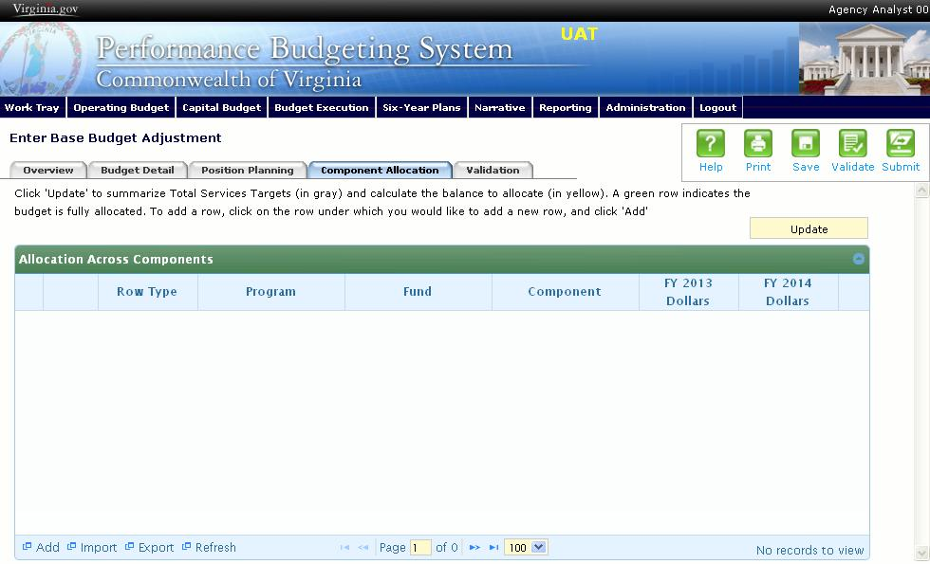
Components Instructions
- Click on the Component Allocation tab.
- Click on the "update" button. This will populate the Component Allocation tab with your budget by program and fund/fund detail as allocated in the base budget total services grid. These lines will appear in the shaded grey rows. The balance to be allocated by component will be in the shaded yellow rows.
- Click on the balance row where you would like to add a new row, and click "Add." In order to select the balance row properly, click the program field in the balance row. Keep adding rows until your budget is fully allocated by component.
- Click the "update" button to check the balance remaining to be allocated. A green shaded row indicates that your budget is fully allocated.
- Components can also be imported into the grid. The best method for this is to export the grid after you have clicked "update." Add component records in the Excel file using the proper ID numbers, and re-import the data set. After you re-import you will need to click "update" again.

NGF Revenue Source Tab

NGF Revenue Source Overview
The purpose of the NGF Revenue Source tab is to capture a six-year estimate of any NGF Revenues that will be generated from the decision package. The revenue estimate should include any nongeneral fund revenue that the agency will collect, receive from another agency, or send to another agency based upon the implementation of the decision package. This tab should only be completed if there is a nongeneral fund request/impact. This is over and above amounts in the six-year nongeneral revenue fund estimates module.

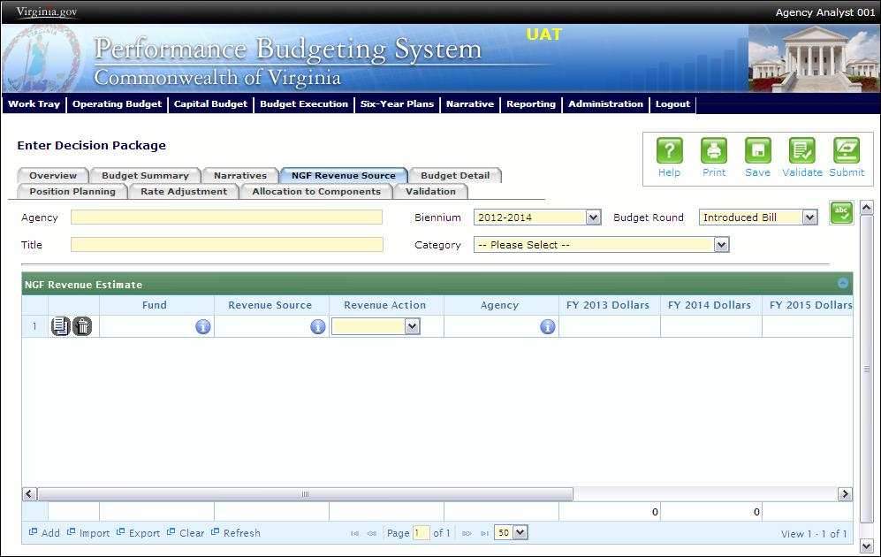
NGF Revenue Source Instructions
- Click on the NGF Revenue Source tab
- In the NGF Revenue Estimate grid, enter the fund and revenue source code associated with the nongeneral fund revenue.
- In the NGF Revenue Estimate grid, select the Revenue Action (send to or receive from) and Agency (pass through or may be blank) associated with that action if applicable.
- In the NGF Revenue Estimate grid, enter an nongeneral fund revenue estimate for six years in the columns labeled with the out-years, FY 20XX Dollars.
- In the NGF Revenue Estimate grid, click on the Methodology cell for revenue source that is currently being estimated. In the popup window that appears, enter the methodology used to make the estimate.
- Add rows to the NGF Revenue Estimate grid as needed to specify multiple nongeneral revenue sources for the decision package by using the button shown below.

Rate Adjustment Tab

Rate Adjustment Tab Overview
The purpose of the Rate Adjustment tab is only for central service agencies that anticipate a change in their assessed rates for internal service fund services they provide to other state government agencies. A spreadsheet showing the impact of the proposed rate change, by agency, must be attached to the Narratives tab.

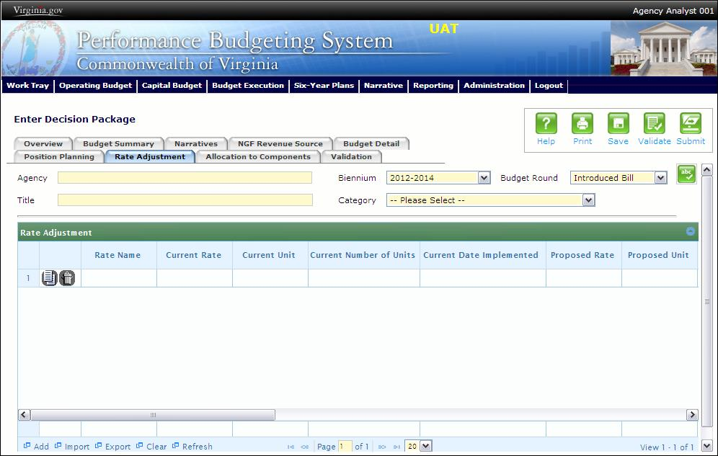
Rate Adjustment Tab Instructions
- Click on the Rate Adjustment tab.
- In the Rate Adjustment grid, enter a Rate Name for rate that will be adjusted.
Enter the official name/title of the rate as it is commonly known.
- In the Rate Adjustment grid, enter the Current Rate, Current Unit, Current Number of Units, and the most Current Date Implemented for the rate that will be adjusted.
- In the Rate Adjustment grid, enter the Proposed Rate, Proposed Unit, Proposed Number of Units, and the Proposed Effective Date for the rate that will be adjusted.
- Enter the FY 20XX Revenue Impact for the rate that will be adjusted, where XX is the first and second years of the biennium and the four out-years.
- Enter the Rationale for Rate Change for the rate that will be adjusted. Associated/required narrative fields can be found on the narratives tab.
Describe the anticipated results or objectives your agency expects to accomplish if the proposed rate adjustment is approved.

Decision Package Prioritization Instructions
Performance Budgeting System
Decision Package Prioritization Overview
The purpose of the Decision Package Prioritization module is to allow an agency to rank decision packages prior to submitting them to DPB. The rank and biennial general fund and nongeneral fund impact is displayed for each decision package. An Agency Analyst or an Agency Reviewer may drag and drop decision packages to create a new decision package ranking for an agency. Decision packages must be ranked prior to submission to DPB.
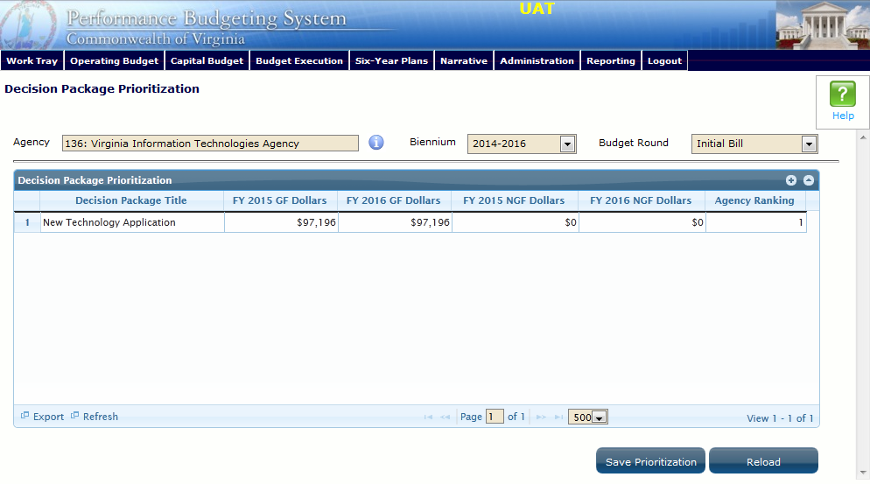
Decision Package Prioritization Instructions
- Click on the Filter by Agency and select an agency to rank the decision packages for an agency.
- Confirm the Biennium and budget round for the decision packages.
- To change the ranking of a decision package in the Decision Package Prioritization grid, click and hold on a decision package that should have a different rank. Move the decision package up or down using the mouse to insert the decision package at a higher or lower ranking. Then, release the mouse. The rankings of all decision packages will then be automatically adjusted. Re-rank as many decision packages as necessary until the desired ranking is achieved.
- While working, if you would like to reload the rankings as they appeared upon the last save, click the Reload button.
- Once the desired ranking is achieved, click the Save Prioritization button to save the decision package ranking for an agency.

Decision Package Bulk Submit Instructions
Performance Budgeting System
Bulk Submit Overview
The purpose of the Decision Package Bulk Submit to DPB module is to allow an agency to submit all their decision packages to DPB at once.
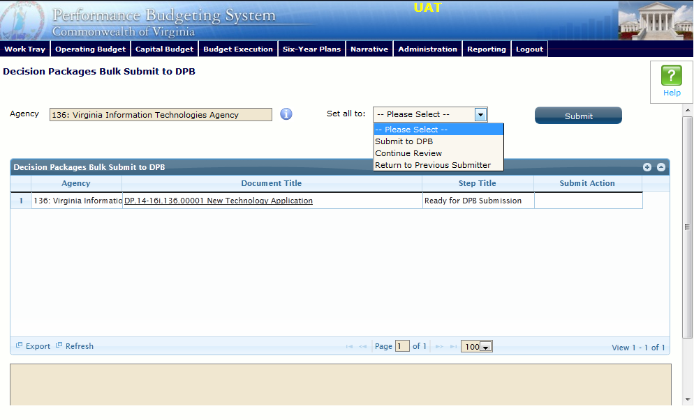
Bulk Submit Instructions
- To ensure that all requests are accounted for, look at the Document Title column to review the base budget adjustments.
- Confirm that the Step Title and State fields are correct for each of the base budget adjustments.
- To bulk manage the submit action, click the Set all to dropdown and select the submit action that the requests require: Submit to DPB, Continue Review, or Return to Previous Submitter. If submitting to DPB, all requests must be set to Submit to DPB. The submit actions correspond to the submit actions in the Decision Package module documentation.
- Click the Submit button. A message will display in the text box below the submit button to alert you that the submission was successful. If you receive a message that one or more work items could not be submitted, you should navigate to the work tray and open the work items to determine if they are failing validation rules for some reason.

